Azim Pathan

Professor Susan Khoee

CIS 3060

5 May 2022

The Game Development Life Cycle

The System Development Life Cycle (SDLC) is an incredibly important process. It provides an effective and well-designed framework to develop software applications. It also offers other benefits such as decreasing project risks, increasing speed of development, improving project management, and reducing management expenses. In this paper we will discuss more details about the GDLC process and understand its importance in business.

**Video Game Industry Revenue**

As it turns out, “The COVID-19 pandemic has propelled the [gaming] industry to make more money than movies and North American sports combined.” (Market Watch) The image to the right shows how well the industry is doing compared to others. From here, we can see that the greatest competitor is Mobile Gaming, with Console Gaming hanging just under it. With so many consumers carrying a smartphone device, the accessibility for gaming has become far larger than ever before.

**Figure 1: Gaming vs. Film vs. Music Industry**

**Why is the Game Development Life Cycle Important?**

The GDLC process is important for a plethora of reasons. These include tapping into enormous market potential, alleviating complex design processes, decreasing potential risks, increasing the speed of development, improving project management, and management expense reduction. All of these aforementioned reasons are what makes the GDLC process widely used in the industry. It helps keeps processes much more manageable for the business as we will see in the planning phase further below.

**Game Development Life Cycle Phases**

There are roughly seven fundamental phases when it comes to the game development process. Keep in mind these phases may have slight alterations depending on the game or business. Nonetheless, the essential phases we will discuss are as follows: Planning Phase, Technical Requirement Analysis Phase, Development Phase, Testing Phase, Pre-Launch Phase, Deployment Phase, and Maintenance. As we will soon see, each of these phases are incredibly important to the overall success of the project.

**Phase 1: Planning**

In the planning phase, we look at several tasks such as the idea or concept of the game in general. It is also just as important to understand who the audience is, as the game’s audience can dictate what type of project it will be entirely. Furthermore, the budget should be discussed as well as how the development process will be sponsored. Otherwise, there could be major delays or cancellation if resources are not properly understood or responsibily utilized. Furthermore, the platform that which the game will be played on is also important, and finally the timeframe. The timeframe for the project dictates how long the process will be from start to end, which further develops our understanding of the scope for the project. The scope will give a general pricing standpoint for the game. Another aspect of the planning process is to help understand whether the project will be profitable or not. The ideas that are set within the planning phase will directly influence the next phase, which is the technical requirement analysis phase.

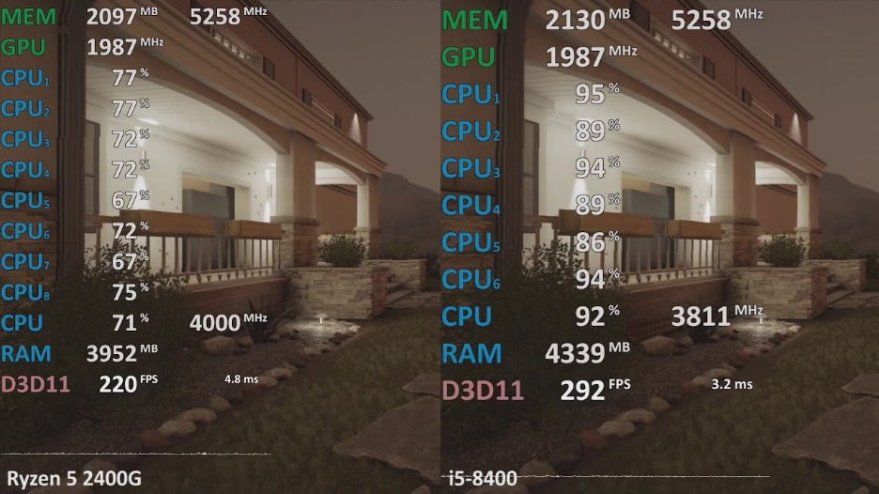**Phase 2: Technical Requirement Analysis**

The sheer complexity of game development will require great understanding of the functional and non-functional requirements. As a recap, functional requiremnents describe what the system is required to do, and non-functional requirements explain how well it is able to do those tasks. This is highly dependent on the game design proposed, however. For example, for a massively multiplayer online role-playing (MMORPG) game, some of the basic requirements are that the system should allow players to login, create their character, connect to other players, join matches, check records and statistics, etc. This may be different for a single-player game played locally, which would not require server hosting entirely. Additionally, non-functional requirements ensure that the game performs well, is scalable, reliable, easily recoverable in emergency situations, simple to maintain, and has a secure infrastructure in place for potential internal and external issues. Some non-functional requirements are analyzed using computer software on multiple machines with varying computer specifications, as shown in the image to the above.

**Figure 2: Gaming Benchmarks | PC Spec Performance Comparison**

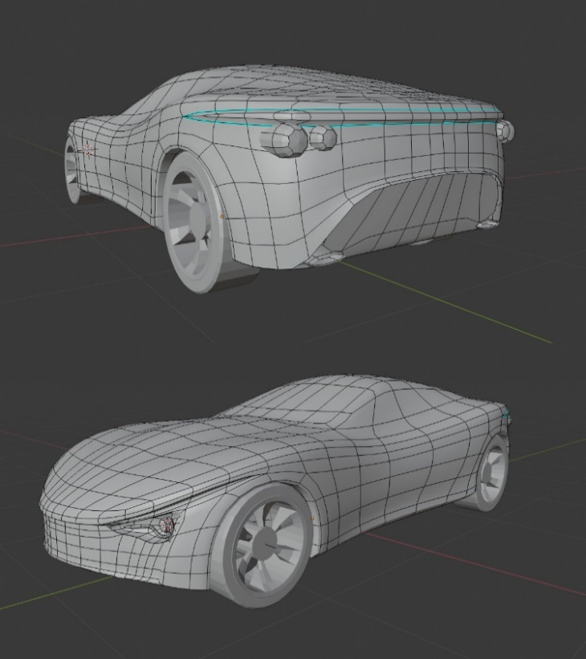**Phase 3: Development**

Game and software development as a whole is an iterative process. Gradually working on bits and pieces of the code, testing it, and continuing the process as it manifests. Development can be a very technical aspect, but from a design perspective, the user interface will be created, audio and sound engineering will be designed, graphical assets, visual effects, the physics engine, servers, and database infrastructures will need to be created as well. Although the testing precedes this process, there is undoubtedly a great amount of minor testing that goes into the development process as well. Many minor tweaks are made, changing different types of functionalities that are more in line with the idea. Sometimes entire levels, plots, or the entire game is scrapped in the event that something down the line might not work out. This is also why the planning phase above is extremely important. As you can see, the phases play out in a tight cycle, with each part of the process directly influencing the others. If each phase is not properly executed, it can be a domino effect of a disaster.

**Figure 3: Realistic Car Assets Modelled in Blender®**

**Phase 4: Play Testing/Debugging**

The play testing phase is quite fun for alpha and beta testers. This is also where the game itself can be marketed to their audience, to get feedback for the game and find out what worked and what did not. It is imperative that bugs are reported, logged, and fixed accordingly as this stage will establish the first impression of the game. Often times, developers will create “demo” versions of the game to be played and reviewed by influencers to gain traction and create buzz. Other aspects such as design philosophy are also extensively reviewed, to ensure that the game not only functions properly, but is also fun to play. What is the point of playing a well functioning game that is not fun?

**Phase 5: Pre-Launch**

Pre launch phase is used to further market the project, gain additional feedback from polls, social media, and other venues of the feedback gathering process. This is also where more bugs are squashed and the game is further polished. A release date is often given to the public, at the very least, its season, such as Winter 2022.

**Phase 6: Deployment**

The deployment phase is where the project is finally released, and users are able to play the game. It is imperative that the non-functional requirements set in phase 2 are monitored very closely, as we will see in phase 7 below

**Phase 7: Maintenance and Monitoring**

Unfortunately for game developers, the development process and overall life cycle of the game is far longer than other forms of entertainment. When a producer makes a film or piece of music, those creative arts are released with no changes expected. However, for game development, in fact, it is just the beginning. To keep the game profitable, it may require a certain period of longevity to meet the threshold. This means that the game is expected to maintain popularity for a certain amount of time to gain enough revenue to cover costs planned and generate profit for the company. Maintenance of the servers, updates to the game in the form of new digital content, and consistent patch updates to ensure the game is running as smooth as possible are to be expected during the process. Simply hosting online servers’ costs money as well, so developers tend to add more than upfront costs for the game. These are in the form of subscriptions, micro-transactions, and the like.

**Conclusion**

To conclude, from the information presented we can see just how important the *Game Development Life Cycle* is, and why it is widely used within the industry. Projects are easier to manage, cheaper to develop, less risky, and can be developed faster with proper planning and supervision of resources available.

Works Cited

1. Aleem, Saiqa, et al. “Game Development Software Engineering Process Life Cycle: A Systematic Review - Journal of Software Engineering Research and Development.” SpringerOpen, Springer Berlin Heidelberg, 9 Nov. 2016, <https://jserd.springeropen.com/articles/10.1186/s40411-016-0032-7>.
2. Ariosoft, et al. “What Is the Game Development Life Cycle?” *Ariosoft*, 2 Dec. 2019, <https://ariosoft.com/what-is-the-game-development-life-cycle/>.
3. “Gaming Industry Nearly Twice as Large as Reported, at $336B.” *BITKRAFT Ventures*, 14 Feb. 2022, https://www.bitkraft.vc/gaming-industry-market-size/.
4. Jain, Sumit. “Game Development Life Cycle.” *LinkedIn*, LinkedIn, 8 Mar. 2018, https://www.linkedin.com/pulse/game-development-life-cycle-sumit-jain/.
5. Jon Quast, Clay Bruning. “This Opportunity for Investors Is Bigger than Movies and Music Combined.” *The Motley Fool*, The Motley Fool, 3 Oct. 2021, https://www.fool.com/investing/2021/10/03/this-opportunity-for-investors-is-bigger-than-movi/.
6. Studygyaan. “7 Stages of SDLC: 7 Phases of SDLC Software Development Life Cycle.” *BETSOL*, 1 Oct. 2021, https://www.betsol.com/blog/7-stages-of-sdlc-how-to-keep-development-teams-running/.
7. “Non-Functional Requirements: Tankwars Project.” *Assembla*, https://app.assembla.com/spaces/tank_wars/wiki/Non-Functional_Requirements.
8. Veteran), Michael "Flashback" Mamerow (Gaming. “Michael ‘Flashback’ Mamerow (Gaming Veteran).” *Raise Your Skillz*, 7 Apr. 2022, https://raiseyourskillz.com/gaming-industry-vs-other-entertainment-industries-2021/.
9. “What Is the Software Development Life Cycle (SDLC) and How Does It Work?” *Synopsys*, https://www.synopsys.com/glossary/what-is-sdlc.html.
10. Witkowski, Wallace. “Videogames Are a Bigger Industry than Movies and North American Sports Combined, Thanks to the Pandemic.” *MarketWatch*, MarketWatch, 22 Dec. 2020, https://www.marketwatch.com/story/videogames-are-a-bigger-industry-than-sports-and-movies-combined-thanks-to-the-pandemic-11608654990.